

WIA2003/WIB2003 PROBABILITY AND STATISTICS

PROJECT REPORT
SEMESTER 1, SESSION 2025/2026

Group: OCC 1

Lecturer: Prof. Ts. Dr. Vimala A/P Balakrishnan

Name | Matric Number
AQIL AIMAN BIN SYUKRI | 23002016
MUHAMMAD AKIF BIN MD NADZIR | 23002826
IRFAN IZZUDDIN BIN AZMI | 23002562
MUHAMMAD FAZARUL AZHAM BIN MOHD FAUZI | 24004544
MUHAMMAD FAKHRUL BIN HASSAN | 23002457
ZHONG XIANHAO | 23072660

INTRODUCTION
1.1. Background of Study

Cyber scams have become an increasingly genuine issue in today’s digital society. With the rapid growth of online platforms, individuals are more exposed to various forms of cyber fraud, including phishing, online shopping scams, and identity theft. These scams not only cause financial losses but also negatively affect victims' psychological well-being and trust in digital systems.

Despite the increasing prevalence of cyber scams, not all individuals are affected in the same way. Some people can identify scam attempts early and respond effectively, while others are more vulnerable. This suggests that factors such as personal awareness, technological familiarity, and behavioral characteristics may play a key role in cyber scam resilience.

1.2. Importance of the Study

This study is important as it seeks to better understand the factors that influence an individual’s ability to resist and cope with cyber scams. By identifying these factors, the findings of this study may help improve awareness programs and contribute to the development of more effective cyber safety strategies.

1.3. Problem Statement

Although cyber scams are widely discussed, there is still limited understanding of why some individuals are more resilient to cyber scams than others. Previous studies have focused on the types and frequency of cyber scams, while fewer studies have examined the role of demographic factors, technological familiarity, and self-awareness in shaping cyber scam resilience. Therefore, this study aims to address this gap by investigating the factors that influence individuals’ ability to resist and respond to cyber scams.

1.4. Objectives of the Study

The objectives of this study are:
1. To examine whether cyber scam victimization is dependent on gender.
2. To investigate whether technological familiarity affects cyber scam resilience.
3. To explore the relationship between self-awareness of online risks and cyber scam resilience.

2. RESEARCH QUESTIONS

RQ1: Is cyber scam victimization independent of gender among respondents?
RQ2: Does the level of technological familiarity significantly affect cyber scam resilience among respondents?
RQ3: Is there a significant relationship between self-awareness of online risks and cyber scam resilience?
3. HYPOTHESIS

Based on the research questions, several hypotheses were formulated in this study.

- Null Hypothesis (H0₁): There is no significant association between gender and cyber scam victimization.
Alternative Hypothesis (H1₁): There is a significant association between gender and cyber scam victimization.
- Null Hypothesis (H0₂): There is no significant difference in cyber scam resilience across distinct levels of technological familiarity.
Alternative Hypothesis (H1₂): There is a significant difference in cyber scam resilience across distinct levels of technological familiarity.
- Null Hypothesis (H0₃): There is no significant relationship between self-awareness and cyber scam resilience.
Alternative Hypothesis (H1₃): There is a significant relationship between self-awareness and cyber scam resilience.

4. METHODOLOGY
4.1 Data collection
This study adopted a quantitative survey designed to investigate factors associated with cyber scam resilience. Data was collected using an online questionnaire developed through Google Forms and exported to IBM SPSS Statistics. The survey targeted individuals aged eighteen and above, including both working adults and students, with a total of 123 respondents participating in the study.
The questionnaire consisted of multiple-choice questions and Likert-scale items ranging from 1 (strongly disagree) to 5 (strongly agree) to assess respondents’ personality traits, as well as their awareness, attitudes, and behaviors related to cyber scams. Some scores were created by computing the mean of the Likert items in all constructs (e.g., Resilience Mean = MEAN (var1, var2, var3)).
4.2 Method
The data collected were analyzed using the IBM SPSS Statistics.
- A Chi-square test of independence was conducted to examine whether cyber scam victimization is independent of gender.
- One-way ANOVA was applied to identify differences in cyber scam resilience across three levels of technological familiarity (Beginner, Intermediate, Advanced). When the overall ANOVA was significant, we performed Post Hoc test to identify which groups differed while controlling family-wise error.
- Pearson correlation analysis was used to determine the strength and direction of relationships between self-awareness of online risks and cyber scam resilience.
Overall, this combination of statistical tests allows the study to examine variable independence, group differences, and linear associations, providing a comprehensive and systematic understanding of the factors influencing cyber scam resilience.

5. RESULTS

This section analyses the results obtained from the statistical tests conducted in the previous section. The findings for each hypothesis are presented using tables and figures to make the results easy to understand. The discussion focuses on explaining what the results mean by highlighting key patterns, significant relationships, and whether the hypotheses are supported or rejected. Raw data are not included in this section and are provided separately in the appendix.

1. Gender and Cyber Scam Victimization
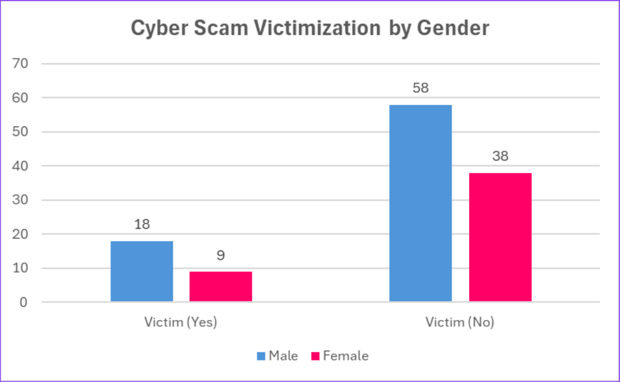
Gender | Victim (Yes) | Victim (No) | Total
Male | 18 | 58 | 76
Female | 9 | 38 | 47
Total | 27 | 96 | 123
Table 1 Diagram 1
The results show that gender is not a significant factor in cyber scam victimization. Although there are slight differences in the number of male and female respondents who reported being victims, these differences are small and not statistically meaningful. This suggests that both males and females face similar exposure to online platforms and scam tactics. Cyber scams are designed to target online behavior rather than specific genders. As a result, resilience to cyber scams is influenced more by awareness, experience, and technological knowledge than by gender alone.
The null hypothesis proposing there is no significant association between gender and cyber scam victimization was rejected.

2. Technological Familiarity and Cyber Scam Resilience
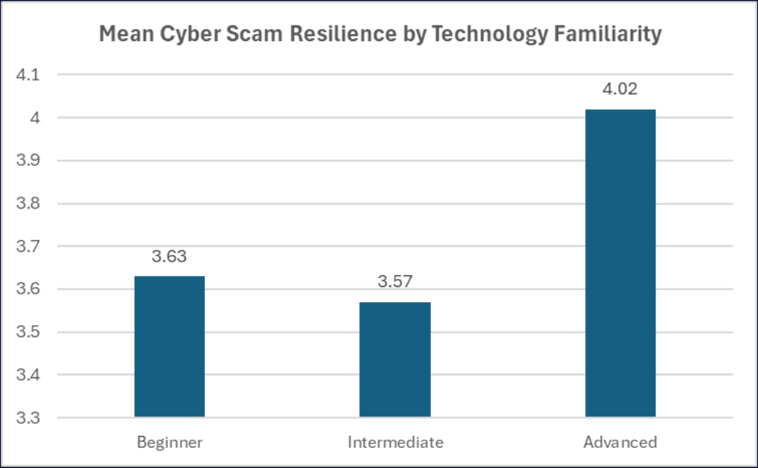
Comparison | Mean Difference | p-value | Significant
Advanced vs Beginner | 0.39 | 0.424 | No
Advanced vs Intermediate | 0.45 | 0.023 | Yes
Beginner vs Intermediate | 0.06 | 0.975 | No
Table 2 Diagram 2
A one-way ANOVA revealed a significant difference in mean cyber scam resilience among respondents with distinct levels of technological familiarity, F (2,120) = 3.72, p = 0.027. Post Hoc tests were conducted following a significant one-way ANOVA. The results showed that respondents with advanced technological familiarity had significantly higher cyber scam resilience scores than those with intermediate familiarity, mean difference = 0.46, p = 0.023. There are no significant differences found between other group comparisons, due to sample size of the beginner group.
The null hypothesis proposing there is no significant difference in cyber scam resilience across distinct levels of technological familiarity was rejected.
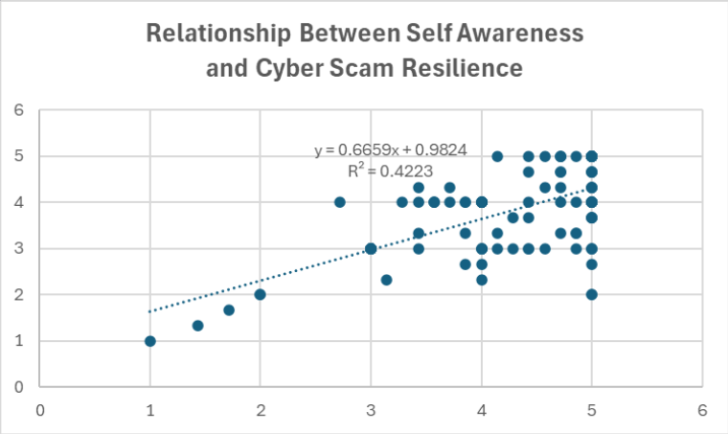
3. Self-Awareness and Cyber Scam Resilience
Variables | Pearson correlation, r | p-value
Self-Awareness Mean x  Resilience Mean | 0.65 | < 0.001

Table 3 Diagram 3
A Pearson correlation analysis revealed a strong positive relationship between self-awareness of online risks and cyber scam resilience, r = 0.65, p < 0.001. This means that as self-awareness increases, resilience towards cyber scams also increases. Individuals who are more aware of online risks are more likely to identify warning signs, think critically before acting, and avoid risky online behavior. This explains the strong correlation observed between self-awareness and cyber scam resilience.
The null hypothesis proposing that there is no significant relationship between self-awareness of online risks and cyber scam resilience was rejected.

6. DISCUSSION
According to the findings, it is concluded that gender, as a variable, is not significantly associated with cyber scam victimization. This could be attributed to the fact that cyber scams are gender neutral since they target the individual’s online behavior rather than his or her demographic characteristics. Furthermore, given the technological adeptness of every segment of society at present, both males and females use similar technological platforms. These platforms could be social media, online shopping websites, or messaging platforms. Thus, the males and females were equally exposed to.

Cyber scam resilience was significantly influenced by the desired technological familiarity. For instance, tech-savvy people will recognize unusual links, fake websites, and abnormal online behavior. The system emulates the real-world scenario where users with greater technological skills operate with more caution but also with more confidence.

The strong positive correlation between one’s self-awareness of online risks and the resilience to cyber scams suggests that awareness is important. Participants who understand common scam tactics are more likely to double-check information on their own and reduce their risk of being scammed.

7. CONCLUSION

This study looked at cyber scam resilience and how it is influenced by gender, technological familiarity, and self-awareness of online risks. The results show that gender does not play a vital role in cyber scam victimization, as both males and females face similar risks online.

However, individuals who are more familiar with technology showed higher cyber scam resilience. This means that people who understand how online platforms and digital systems work are better at identifying and avoiding scams. In addition, self-awareness of online risks was strongly related to cyber scam resilience. People who are more aware of common scam tactics are more careful and less likely to fall victim to scams.

The findings of this study are useful because they show that education and awareness are key factors in reducing cyber scam risks. Improving digital literacy and cyber awareness can help individuals protect themselves more effectively from online scams.

REFERENCES
- Muhammad Adnan Pitchan, Salman, A., & Nadhirah Muhamad Arib. (2025). A Systematic Literature Review on Online Scams: Insights into Digital Literacy, Technological Innovations, and Victimology. Jurnal Komunikasi Malaysian Journal of Communication, 41(1), 107–124. https://doi.org/10.17576/jkmjc-2025-4101-07
- Balcombe, L. (2025). The Mental Health Impacts of Internet Scams. International Journal of Environmental Research and Public Health, 22(6), 938. https://doi.org/10.3390/ijerph22060938
- Sultana, S. (2025). Examining Online Scamming Techniques: How Scammers Contact and Influence Victims to Enhance Public Awareness. Social Sciences, 01(01), 28–38. https://doi.org/10.11648/j.scif.20250101.14

APPENDIX

Appendix A: Questionnaire
The copy of questionnaire used in this study can be accessed at the following link: Questionnaire OCC 1 GROUP 17

Appendix B: Raw Survey Data
The raw survey data collected from respondents in CSV format can be accessed at the following link: Raw Data of Survey

